TO Study Template matching in robotics.
Exp
No 5

Aim: TO Study Template matching in robotics.

Instrument Required:
Desktop PC with Internet connection:

In robotics, template matching is a computer vision technique used to find a small reference image (the template) within a larger source image. It is a foundational method for robotic perception and is widely used for tasks like object detection, pose estimation, and navigation

How It Works:

The process typically follows a "sliding window" approach:
1.Sliding: The template is moved across the target image pixel by pixel.
2.Comparison: At each position, a mathematical metric calculates the 3.similarity between the template and the underlying image patch.
4.Localization: The coordinates with the highest similarity score (the "peak") are identified as the object's location.

Template Image:
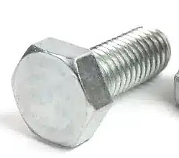

Objects Image:
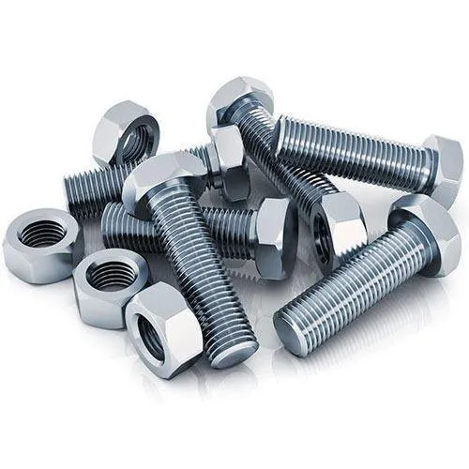

Python Code for Template matching:
import cv2
import numpy as np
from google.colab.patches import cv2_imshow

# Read images
img = cv2.imread('scene.jpg')

# Check if image is loaded successfully
if img is None:
print("Error: Could not load 'scene.jpg'. Please ensure the file exists in the correct directory.")
exit()

gray_img = cv2.cvtColor(img, cv2.COLOR_BGR2GRAY)

template = cv2.imread('template.jpg', 0)

# Check if template is loaded successfully
if template is None:
print("Error: Could not load 'template.jpg'. Please ensure the file exists in the correct directory.")
exit()

w, h = template.shape[::-1]

# Template matching
result = cv2.matchTemplate(gray_img, template, cv2.TM_CCOEFF_NORMED)

# Get best match
min_val, max_val, min_loc, max_loc = cv2.minMaxLoc(result)

top_left = max_loc
bottom_right = (top_left[0] + w, top_left[1] + h)

# Draw rectangle
cv2.rectangle(img, top_left, bottom_right, (0, 255, 0), 2)

# Show output
cv2_imshow(img)
cv2.waitKey(0)
cv2.destroyAllWindows()

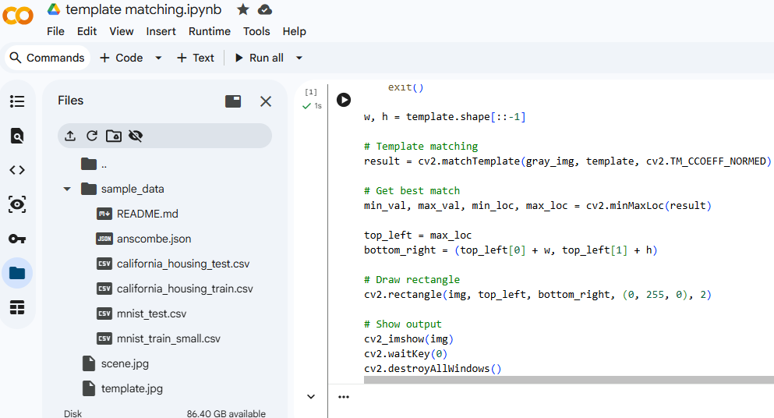

Result:
